**SCC**

**Sistema de Controle de Chamados**

Esse documento tem como objetivo descrever como está implementado o banco de dados do Sistema de Controle de Chamados (SCC).

**Diagrama entidade relacionamento**

**Sistema de Controle de Chamados**

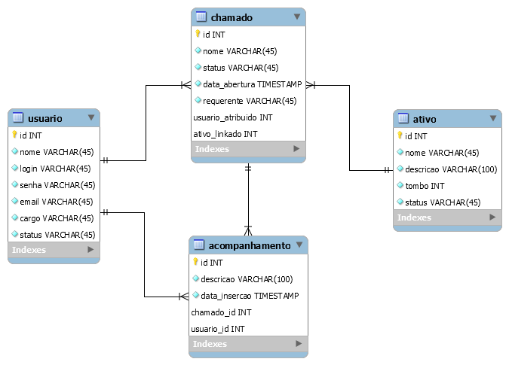

**Modelo físico**

**Sistema de Controle de Chamados**

*use `id9282948_scc`;*

*-- MySQL Script generated by MySQL Workbench*

*-- Sun Apr 28 19:47:16 2019*

*-- Model: New Model Version: 1.0*

*-- MySQL Workbench Forward Engineering*

*SET @OLD_UNIQUE_CHECKS=@@UNIQUE_CHECKS, UNIQUE_CHECKS=0;*

*SET @OLD_FOREIGN_KEY_CHECKS=@@FOREIGN_KEY_CHECKS, FOREIGN_KEY_CHECKS=0;*

*SET @OLD_SQL_MODE=@@SQL_MODE, SQL_MODE='ONLY_FULL_GROUP_BY,STRICT_TRANS_TABLES,NO_ZERO_IN_DATE,NO_ZERO_DATE,ERROR_FOR_DIVISION_BY_ZERO,NO_ENGINE_SUBSTITUTION';*

*-- -----------------------------------------------------*

*-- Schema mydb*

*-- -----------------------------------------------------*

*-- -----------------------------------------------------*

*-- Table `usuario`*

*-- -----------------------------------------------------*

*CREATE TABLE IF NOT EXISTS `usuario` (*

*`id` INT UNSIGNED NOT NULL AUTO_INCREMENT,*

*`nome` VARCHAR(45) NOT NULL,*

*`login` VARCHAR(45) NOT NULL,*

*`senha` VARCHAR(45) NOT NULL,*

*`email` VARCHAR(45) NOT NULL,*

*`cargo` VARCHAR(45) NOT NULL,*

*`status` VARCHAR(45) NOT NULL,*

*PRIMARY KEY (`id`),*

*UNIQUE INDEX `login_UNIQUE` (`login` ASC),*

*UNIQUE INDEX `email_UNIQUE` (`email` ASC),*

*UNIQUE INDEX `id_UNIQUE` (`id` ASC))*

*ENGINE = InnoDB;*

*-- -----------------------------------------------------*

*-- Table `ativo`*

*-- -----------------------------------------------------*

*CREATE TABLE IF NOT EXISTS `ativo` (*

*`id` INT UNSIGNED NOT NULL AUTO_INCREMENT,*

*`nome` VARCHAR(45) NOT NULL,*

*`descricao` VARCHAR(100) NOT NULL,*

*`tombo` INT NOT NULL,*

*`status` VARCHAR(45) NOT NULL,*

*PRIMARY KEY (`id`),*

*UNIQUE INDEX `tombo_UNIQUE` (`tombo` ASC))*

*ENGINE = InnoDB;*

*-- -----------------------------------------------------*

*-- Table `chamado`*

*-- -----------------------------------------------------*

*CREATE TABLE IF NOT EXISTS `chamado` (*

*`id` INT UNSIGNED NOT NULL AUTO_INCREMENT,*

*`nome` VARCHAR(45) NOT NULL,*

*`status` VARCHAR(45) NOT NULL,*

*`data_abertura` TIMESTAMP NOT NULL DEFAULT current_timestamp(),*

*`requerente` VARCHAR(45) NOT NULL,*

*`usuario_atribuido` INT UNSIGNED NOT NULL,*

*`ativo_linkado` INT UNSIGNED NOT NULL,*

*PRIMARY KEY (`id`, `usuario_atribuido`, `ativo_linkado`),*

*INDEX `fk_chamado_usuario1_idx` (`usuario_atribuido` ASC),*

*INDEX `fk_chamado_ativo1_idx` (`ativo_linkado` ASC),*

*CONSTRAINT `fk_chamado_usuario1`*

*FOREIGN KEY (`usuario_atribuido`)*

*REFERENCES `usuario` (`id`)*

*ON DELETE NO ACTION*

*ON UPDATE NO ACTION,*

*CONSTRAINT `fk_chamado_ativo1`*

*FOREIGN KEY (`ativo_linkado`)*

*REFERENCES `ativo` (`id`)*

*ON DELETE NO ACTION*

*ON UPDATE NO ACTION)*

*ENGINE = InnoDB;*

*-- -----------------------------------------------------*

*-- Table `acompanhamento`*

*-- -----------------------------------------------------*

*CREATE TABLE IF NOT EXISTS `acompanhamento` (*

*`id` INT NOT NULL AUTO_INCREMENT,*

*`descricao` VARCHAR(100) NOT NULL,*

*`data_insercao` TIMESTAMP NOT NULL DEFAULT current_timestamp(),*

*`chamado_id` INT UNSIGNED NOT NULL,*

*`usuario_id` INT UNSIGNED NOT NULL,*

*PRIMARY KEY (`id`, `chamado_id`, `usuario_id`),*

*UNIQUE INDEX `id_UNIQUE` (`id` ASC),*

*INDEX `fk_acompanhamento_chamado1_idx` (`chamado_id` ASC),*

*INDEX `fk_acompanhamento_usuario1_idx` (`usuario_id` ASC),*

*CONSTRAINT `fk_acompanhamento_chamado1`*

*FOREIGN KEY (`chamado_id`)*

*REFERENCES `chamado` (`id`)*

*ON DELETE NO ACTION*

*ON UPDATE NO ACTION,*

*CONSTRAINT `fk_acompanhamento_usuario1`*

*FOREIGN KEY (`usuario_id`)*

*REFERENCES `usuario` (`id`)*

*ON DELETE NO ACTION*

*ON UPDATE NO ACTION)*

*ENGINE = InnoDB;*

*SET SQL_MODE=@OLD_SQL_MODE;*

*SET FOREIGN_KEY_CHECKS=@OLD_FOREIGN_KEY_CHECKS;*

*SET UNIQUE_CHECKS=@OLD_UNIQUE_CHECKS;*